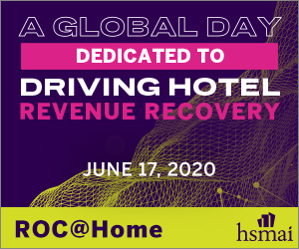 | 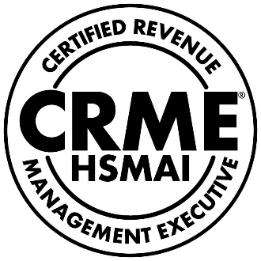

Certified Revenue Management Executive (CRME)

Professional Development Tracker

for initial application and recertification

CRME applications and recertifications require on-going professional development.

Track your ROC@Home professional development credits here and file them for when you need them!

Course Name |  | Date  Watched | Points | Attended?
Pre-recorded presentations | Command Your Mindset keynote with Dr. Jannell MacAuley |  | .5 | Yes
 | Pricing Psychology in Challenging Times webinar |  | .5 | Yes
 | Marketing in a Zero Click World |  | .25 | Yes
 | AI & Machine Learning for Business Leaders |  | .25 | Yes
 | Better in 6m 40s |  | .25 | Yes
 | 80 Hours in October – Key Learnings Hurricane Michael |  | .25 | Yes
 | Revenue Management — The Good, the Bad, and the Ugly |  | .25 | Yes
 | Get Their Hands Out of Your Cookie Jar! |  | .25 | Yes
 | Driving the Revenue Management Culture Past Rooms |  | .25 | Yes
 | How to Own Your Owner |  | .25 | Yes
 | What’s Different About Revenue Management in Franchised Hotels? |  | .25 | Yes
ROC@Home LIVE Sessions
 | TOTAL PROFESSIONAL DEVELOPMENT HOURS |  | _____

Questions? We’re here to help!
Contact Kathy Tindell at +1 703-506-2010 or ktindell@hsmai.org.

